TOPIC NAME- GOLD PRICE ANALYSIS AND FORECASTING OVER TIME

Subject – Data Science

CA-2

Name: Aastha Bane
Roll No: T23005
Class: TY-Bscit

- Introduction
Gold has always played an important role in the Indian economy. It is not only used for jewellery but also considered a safe investment option during inflation, economic uncertainty, and festivals. The price of gold keeps changing daily due to factors such as global market trends, demand–supply, inflation, currency value, and seasonal demand.

- Because gold prices fluctuate frequently, it becomes difficult for investors, traders, and common people to understand:
- When gold prices increase or decrease
- Which months or seasons show higher prices
- What could be the expected future price

- This project “Gold Price Analysis & Forecasting System” helps users analyze historical gold price data, understand trends, study seasonal patterns, and predict future prices using data science techniques.
- The system is built using Python, Pandas, Streamlit, and time-series analysis, and it provides an interactive dashboard for easy understanding.

- Problem Statement
Gold prices change every day and show different patterns across months, years, and seasons. However:
- Raw gold price data is difficult to understand for normal users
- There is no simple visual system to analyze yearly, monthly, and seasonal trends together
- People cannot easily predict future gold prices based on historical data
- Seasonal price movements (summer, monsoon, winter) are not clearly visible

Problem
There is a need for an interactive and easy-to-use system that can analyze historical gold prices, detect trends and seasonality, and predict future gold prices accurately.

- Why Are We Implementing This Topic?
This topic is implemented because:
- Gold is a major investment asset in India
- Seasonal demand (weddings, festivals, monsoon, inflation) affects prices
- Investors need data-driven insights instead of guesswork
- Data science and forecasting models can help predict future prices
- This project applies real-world data science concepts practically
It also helps students understand:
- Data preprocessing
- Time-series analysis
- Forecasting techniques
- Data visualization
- Dashboard development using Streamlit

- Objectives
The main objectives of this project are:
- To analyze historical gold price data from past years
- To show monthly and yearly gold price trends using visual dashboards
- To predict future gold prices based on selected dates
- To study seasonal behavior of gold prices (Summer, Monsoon, Winter)
- To provide an interactive dashboard for better understanding
- To help users make informed investment decisions
- To identify the best month to buy gold based on historical average prices.
- To allow users to filter data year-wise for more focused analysis.
- To provide users with the option to download analyzed gold price data for offline use.

- Methodology
The project follows these steps:
- Data Collection
- Historical gold price data (Date, Price, Open, High, Low, Volume)
- Data ranges from 2014 to 2025
- Data stored in CSV format (Gold Price.csv)
- Data Preprocessing
- Converted date column into datetime format
- Cleaned missing and invalid values
- Sorted data by date
- Converted price values to numeric format
- Prepared monthly and yearly aggregates
- Data Analysis
- Monthly average gold price analysis
- Yearly average gold price analysis
- Seasonal grouping (Summer, Monsoon, Winter)
- Forecasting
- Time-series forecasting model used
- User selects future date
- System predicts gold price for that date
- Visualization
- Line charts for trend analysis
- Bar charts for comparison
- Interactive hover tooltips for values
- Season-wise visual comparison
- Dashboard Development
- Built using Streamlit
- Sidebar filters for year, season, and chart type
- Multiple pages for different features
- Users can download gold price data for offline analysis

Features of the System

Feature 1: Dashboard – Gold Price Overview
- Main dashboard showing gold price trends
- Monthly and yearly filters
- Visual representation using line charts
- Helps users quickly understand price movement

Feature 2: Monthly & Yearly Average Analysis
- Displays average gold prices:
  - Month-wise
  - Year-wise
- Helps identify:
  - Which year had highest prices
  - Which month generally has higher prices
- Useful for long-term investment analysis

Feature 3: Gold Price Forecasting
- User selects a future date
- Clicks Predict button
- System predicts gold price per 10 grams
- Based on historical price trends
- Useful for planning future purchases or investments

Feature 4: Best Month to Buy Gold
- Identifies the best month to buy gold based on historical average prices
- Allows users to select a specific year for analysis
- Displays the month with the lowest average gold price
- Helps users make cost-effective purchasing decisions

Feature 5: Seasonality Analysis
- Shows how gold prices behave in different seasons:
  - Summer
  - Monsoon
  - Winter
- User selects:
  - Year
  - Season
  - Chart type (Line / Bar)
- Interactive chart with hover values
- Helps understand seasonal demand impact on gold prices

Feature 6: Data Download Option
- Allows users to download historical gold price data in CSV format
- Download option is available in the sidebar
- Enables offline analysis and record keeping

Technologies Used
- Python – Core programming language
- Pandas – Data manipulation and analysis
- NumPy – Numerical computations
- Streamlit – Web dashboard and UI
- Matplotlib / Plotly – Data visualization
- Time Series Analysis – Forecasting gold prices
- CSV Dataset – Data storage

Advantages of the System
- Easy to understand visual dashboard
- Interactive filters for better analysis
- Helps investors make data-driven decisions
- Shows seasonal price behavior clearly
- Reduces dependency on manual analysis
- Real-world application of data science concepts

Limitations
- Prediction depends only on historical data
- External factors like global economy, wars, inflation are not directly included
- Forecast accuracy may reduce for long-term future dates
- Dataset quality affects prediction results

Future Enhancements
- Add real-time gold price API
- Include inflation and currency exchange data
- Improve prediction using advanced models (SARIMA, LSTM)
- Add price comparison between cities
- Add buy/sell recommendation system
- Mobile app version

- Codes:
App.py
import streamlit as st
import pandas as pd
import plotly.express as px

def load_css():
with open("style.css", encoding="utf-8") as f:
st.markdown(f"<style>{f.read()}</style>", unsafe_allow_html=True)

load_css()

st.set_page_config(page_title="Indian Gold Price Dashboard", layout="wide")

st.title("📈 Indian Gold Price Trend ")
st.write("Long-term Gold Price Trend Analysis")

# Load data
df = pd.read_csv("Gold Price.csv")

# Date processing
df["Date"] = pd.to_datetime(df["Date"])
df["Year"] = df["Date"].dt.year
df["Month"] = df["Date"].dt.month
df["Month_Name"] = df["Date"].dt.strftime("%B")

# Sidebar
st.sidebar.header("Filters")
view_type = st.sidebar.radio("Select View Type", ["Yearly Trend", "Monthly Trend"])

# ---------------- YEARLY TREND ----------------
if view_type == "Yearly Trend":
yearly_avg = df.groupby("Year")["Price"].mean().reset_index()

fig = px.line(
yearly_avg,
x="Year",
y="Price",
markers=True,
title="Year-wise Average Gold Price (₹ per 10g)",
labels={"Price": "Gold Price (₹/10g)"},
)
st.plotly_chart(fig, use_container_width=True)

# ---------------- MONTHLY TREND ----------------
else:
selected_year = st.sidebar.selectbox("Select Year", sorted(df["Year"].unique()))

monthly_avg = (
df[df["Year"] == selected_year]
.groupby(["Month", "Month_Name"])["Price"]
.mean()
.reset_index()
.sort_values("Month")
)

fig = px.line(
monthly_avg,
x="Month_Name",
y="Price",
markers=True,
title=f"Monthly Average Gold Price in {selected_year} (₹ per 10g)",
labels={"Price": "Gold Price (₹/10g)", "Month_Name": "Month"},
)
st.plotly_chart(fig, use_container_width=True)

# ---------------- DOWNLOAD DATA ----------------
st.sidebar.markdown("---")
st.sidebar.subheader("⬇️ Download Data")

st.sidebar.download_button(
label="Download Gold Price Data (CSV)",
data=df.to_csv(index=False),
file_name="gold_price_data.csv",
mime="text/csv",
)

Monthly & Yearly Average.py

import streamlit as st
import pandas as pd
import plotly.express as px
import streamlit as st

def load_css():
with open("style.css", encoding="utf-8") as f:
st.markdown(f"<style>{f.read()}</style>", unsafe_allow_html=True)

load_css()
import streamlit as st

st.set_page_config(page_title="Average Gold Price Analysis", layout="wide")

st.title("📊 Monthly & Yearly Average Gold Price Analysis")

# Load data
df = pd.read_csv("Gold Price.csv")
df["Date"] = pd.to_datetime(df["Date"])
df["Year"] = df["Date"].dt.year
df["Month"] = df["Date"].dt.month
df["Month_Name"] = df["Date"].dt.strftime("%B")

# ---------------- YEARLY AVERAGE ----------------
st.subheader("Year-wise Average Gold Price (₹ per 10g)")
yearly_avg = df.groupby("Year")["Price"].mean().reset_index()

fig1 = px.bar(
yearly_avg,
x="Year",
y="Price",
title="Average Gold Price by Year",
labels={"Price": "Avg Price (₹/10g)"},
)
st.plotly_chart(fig1, use_container_width=True)

# ---------------- MONTHLY AVERAGE ----------------
st.subheader("Month-wise Average Gold Price (Selected Year)")
selected_year = st.selectbox("Select Year", sorted(df["Year"].unique()))

monthly_avg = (
df[df["Year"] == selected_year]
.groupby(["Month", "Month_Name"])["Price"]
.mean()
.reset_index()
.sort_values("Month")
)

fig2 = px.bar(
monthly_avg,
x="Month_Name",
y="Price",
title=f"Monthly Average Gold Price in {selected_year}",
labels={"Price": "Avg Price (₹/10g)", "Month_Name": "Month"},
)
st.plotly_chart(fig2, use_container_width=True)

st.sidebar.markdown("---")
st.sidebar.subheader("⬇️ Download Data")

st.sidebar.download_button(
label="Download Gold Price Data (CSV)",
data=df.to_csv(index=False),
file_name="gold_price_data.csv",
mime="text/csv",
)

Forecasting.py

import streamlit as st
import pandas as pd
from statsmodels.tsa.statespace.sarimax import SARIMAX
import streamlit as st

def load_css():
with open("style.css", encoding="utf-8") as f:
st.markdown(f"<style>{f.read()}</style>", unsafe_allow_html=True)

load_css()
import streamlit as st

# ---------------- Page Config ----------------
st.set_page_config(page_title="Gold Price Forecasting", layout="centered")
st.title("🔮 Gold Price Forecasting ")
st.write("Predict future gold prices based on historical trends")

# ---------------- Load Data ----------------
df = pd.read_csv("Gold Price.csv")

df["Date"] = pd.to_datetime(df["Date"])
df["Price"] = pd.to_numeric(df["Price"], errors="coerce")

df = df.sort_values("Date")
df = df.set_index("Date")

# ---------------- Monthly Resample ----------------
monthly_price = df["Price"].resample("ME").mean()

# Forward fill missing values
monthly_price = monthly_price.ffill()

# ---------------- Train Model ----------------
model = SARIMAX(
monthly_price,
order=(1, 1, 1),
seasonal_order=(1, 1, 1, 12),
enforce_stationarity=False,
enforce_invertibility=False,
)

results = model.fit(disp=False)

# ---------------- UI Input ----------------
st.subheader("📅 Select a future date")
future_date = st.date_input(
"Choose a future date", min_value=monthly_price.index.max().date()
)

# ---------------- Predict Button ----------------
if st.button("🔮 Predict Gold Price"):
future_date = pd.to_datetime(future_date)

months_ahead = (future_date.year - monthly_price.index[-1].year) * 12 + (
future_date.month - monthly_price.index[-1].month
)

if months_ahead <= 0:
st.warning("Please select a future date.")
else:
forecast = results.forecast(steps=months_ahead)
predicted_price = forecast.iloc[-1]

st.success(
f"💰 **Predicted Gold Price on {future_date.strftime('%B %Y')}**\n\n"
f"### ₹ {predicted_price:,.0f} per 10 grams"
)

with st.expander("📘 How this prediction works"):
st.write(
"""
• Uses **monthly gold price trends**
• SARIMAX captures **trend + seasonality**
• Prediction changes as date changes
• Prices shown are **₹ per 10 grams**
"""
)

st.sidebar.markdown("---")
st.sidebar.subheader("⬇️ Download Data")

st.sidebar.download_button(
label="Download Gold Price Data (CSV)",
data=df.to_csv(index=False),
file_name="gold_price_data.csv",
mime="text/csv",
)

Best month to buy.py

import streamlit as st
import pandas as pd

# ---------- LOAD CSS ----------
def load_css():
with open("style.css", encoding="utf-8") as f:
st.markdown(f"<style>{f.read()}</style>", unsafe_allow_html=True)

load_css()

# ---------- PAGE CONFIG ----------
st.set_page_config(page_title="Best Month to Buy Gold", layout="wide")

# ---------- TITLE ----------
st.title("🟢 Best Month to Buy Gold")
st.write("Find the best month to buy gold based on historical average prices")

# ---------- LOAD DATA ----------
df = pd.read_csv("Gold Price.csv")
df["Date"] = pd.to_datetime(df["Date"])
df["Year"] = df["Date"].dt.year
df["Month_Name"] = df["Date"].dt.strftime("%B")

# ---------- YEAR FILTER ----------
selected_year = st.selectbox("Select Year", sorted(df["Year"].unique(), reverse=True))

filtered_df = df[df["Year"] == selected_year]

# ---------- CALCULATE BEST MONTH ----------
monthly_avg = filtered_df.groupby("Month_Name")["Price"].mean().reset_index()

best_row = monthly_avg.loc[monthly_avg["Price"].idxmin()]
best_month = best_row["Month_Name"]
best_price = best_row["Price"]

# ---------- DISPLAY RESULT ----------
st.markdown(
f"""
<div style="
border: 2px solid #facc15;
border-radius: 12px;
padding: 25px;
background: #0e0e12;
text-align: center;
margin-top: 30px;
">
<h2 style="color:#facc15;">Best Month to Buy Gold ({selected_year})</h2>
<h1 style="color:#ffffff;">{best_month}</h1>
<p style="font-size:18px;">
Average Price: <strong>₹ {best_price:,.0f}</strong> per 10 grams
</p>
</div>
""",
unsafe_allow_html=True,
)

# ---------- OPTIONAL TABLE ----------
with st.expander("📊 View Monthly Average Prices"):
st.dataframe(monthly_avg.sort_values("Price"))

st.sidebar.markdown("---")
st.sidebar.subheader("⬇️ Download Data")

st.sidebar.download_button(
label="Download Gold Price Data (CSV)",
data=df.to_csv(index=False),
file_name="gold_price_data.csv",
mime="text/csv",
)

Seasonality.py

import streamlit as st
import pandas as pd
import plotly.express as px

def load_css():
with open("style.css", encoding="utf-8") as f:
st.markdown(f"<style>{f.read()}</style>", unsafe_allow_html=True)

load_css()
# -----------------------------
# Page Config
# -----------------------------
st.set_page_config(page_title="Seasonality Analysis", layout="wide")
st.title("🌦️ Gold Price Seasonality Analysis")

# -----------------------------
# Load Data
# -----------------------------
df = pd.read_csv("Gold Price.csv")
df["Date"] = pd.to_datetime(df["Date"])
df["Price"] = pd.to_numeric(df["Price"], errors="coerce")

df["Year"] = df["Date"].dt.year
df["Month"] = df["Date"].dt.month
df["Month_Name"] = df["Date"].dt.strftime("%B")

# -----------------------------
# Season Mapping
# -----------------------------
def get_season(month):
if month in [3, 4, 5]:
return "Summer"
elif month in [6, 7, 8, 9]:
return "Monsoon"
else:
return "Winter"

df["Season"] = df["Month"].apply(get_season)

# -----------------------------
# Sidebar Filters
# -----------------------------
st.sidebar.header("Filters")

year_selected = st.sidebar.selectbox(
"Select Year", sorted(df["Year"].unique(), reverse=True)
)

season_selected = st.sidebar.selectbox("Select Season", ["Summer", "Monsoon", "Winter"])

chart_type = st.sidebar.radio("Select Chart Type", ["Line Chart", "Bar Chart"])

# -----------------------------
# Filter Data
# -----------------------------
filtered_df = df[(df["Year"] == year_selected) & (df["Season"] == season_selected)]

monthly_avg = (
filtered_df.groupby(["Month", "Month_Name"], as_index=False)["Price"]
.mean()
.sort_values("Month")
)

# -----------------------------
# Plot
# -----------------------------
st.subheader(f"{season_selected} Gold Price Trend — {year_selected}")

if chart_type == "Line Chart":
fig = px.line(
monthly_avg,
x="Month_Name",
y="Price",
markers=True,
hover_data={"Price": ":,.0f"},
title="Seasonal Gold Price Trend",
)
else:
fig = px.bar(
monthly_avg,
x="Month_Name",
y="Price",
hover_data={"Price": ":,.0f"},
title="Seasonal Gold Price Comparison",
)

fig.update_layout(
xaxis_title="Month", yaxis_title="Gold Price (₹ per 10g)", hovermode="x unified"
)

st.plotly_chart(fig, use_container_width=True)

# -----------------------------
# Explanation Box (for viva)
# -----------------------------
st.info(
f"""
📌 **Insight**
This chart shows how gold prices behave during **{season_selected} season in {year_selected}**.
Hover over the chart to see exact monthly prices.
"""
)
st.sidebar.markdown("---")
st.sidebar.subheader("⬇️ Download Data")

st.sidebar.download_button(
label="Download Gold Price Data (CSV)",
data=df.to_csv(index=False),
file_name="gold_price_data.csv",
mime="text/csv",
)

Style.css

/* ============================================================
CYBER-INDUSTRIAL GOLD UI (FINAL)
Sharp • Dark • Professional • Chart-Optimized
============================================================ */

/* --- REMOVE TOOLBAR & FOOTER (KEEP HEADER FOR SIDEBAR TOGGLE) --- */
section[data-testid="stToolbar"],
footer {
display: none !important;
}

/* --- GLOBAL BACKGROUND --- */
.stApp {
background-color: #050505 !important;
background-image:
radial-gradient(at 0% 0%, rgba(250, 204, 21, 0.05) 0px, transparent 50%),
radial-gradient(at 100% 100%, rgba(30, 58, 138, 0.08) 0px, transparent 50%);
color: #ffffff !important;
font-family: "Segoe UI", system-ui, sans-serif;
}

/* --- MAIN CONTENT WIDTH --- */
.block-container {
max-width: 1200px;
padding: 2.5rem 2rem;
}

/* --- SECTION / CARD BOXES --- */
[data-testid="stVerticalBlock"] > div:has(div[data-testid="stPlotlyChart"]),
div[data-testid="stMetric"],
.stTabs,
.stContainer {
background: #0e0e12 !important;
border: 2px solid #2d2d33 !important;
border-top: 4px solid #facc15 !important;
border-radius: 14px !important;
padding: 28px !important;
margin-bottom: 24px !important;
box-shadow: 0 12px 30px rgba(0,0,0,0.7) !important;
}

/* --- TITLES --- */
h1 {
font-size: 3rem !important;
font-weight: 900 !important;
color: #facc15 !important;
text-transform: uppercase;
letter-spacing: 2px;
border-bottom: 2px solid #facc15;
padding-bottom: 10px;
margin-bottom: 35px !important;
}

h2, h3, p, span, label {
color: #ffffff !important;
}

/* --- SIDEBAR --- */
section[data-testid="stSidebar"] {
background-color: #000000 !important;
border-right: 2px solid #facc15 !important;
}

section[data-testid="stSidebar"] * {
color: #ffffff !important;
font-size: 1.05rem !important;
}

/* --- SIDEBAR NAV --- */
div[role="radiogroup"] label {
background: #111114;
border: 1px solid #333;
padding: 12px;
border-radius: 8px;
margin-bottom: 10px;
}

div[role="radiogroup"] label:has(input:checked) {
border: 1px solid #facc15 !important;
background: rgba(250, 204, 21, 0.12) !important;
}

/* --- BUTTONS --- */
.stButton button {
border: 2px solid #facc15 !important;
background: transparent !important;
color: #facc15 !important;
font-weight: 700 !important;
text-transform: uppercase;
border-radius: 6px !important;
height: 3em !important;
}

.stButton button:hover {
background: #facc15 !important;
color: #000 !important;
}

/* --- CHART OVERRIDES --- */
.js-plotly-plot .plotly .main-svg {
background: transparent !important;
}

/* --- GRID + TITLE POLISH --- */
.js-plotly-plot .gridlayer path {
stroke-dasharray: 4 4;
}

.js-plotly-plot .plotly .gtitle {
letter-spacing: 1px;
text-transform: uppercase;
}
/* =================================================
SIDEBAR DOWNLOAD BUTTON (FEATURE 8)
================================================= */

/* Target Streamlit download button in sidebar */
section[data-testid="stSidebar"] .stDownloadButton button {
width: 100%;
background: transparent !important;
border: 2px solid #facc15 !important;
color: #facc15 !important;
font-weight: 700 !important;
text-transform: uppercase;
letter-spacing: 1px;
padding: 10px 12px !important;
border-radius: 6px !important;
margin-top: 10px;
transition: all 0.25s ease-in-out;
}

/* Hover effect */
section[data-testid="stSidebar"] .stDownloadButton button:hover {
background: #facc15 !important;
color: #000000 !important;
box-shadow: 0 0 12px rgba(250, 204, 21, 0.6);
}

/* Remove focus blue outline */
section[data-testid="stSidebar"] .stDownloadButton button:focus {
outline: none !important;
box-shadow: none !important;
}

Requirements.txt

streamlit
pandas
matplotlib
numpy
scikit-learn
statsmodels

- Screenshots:-

Yearly trend

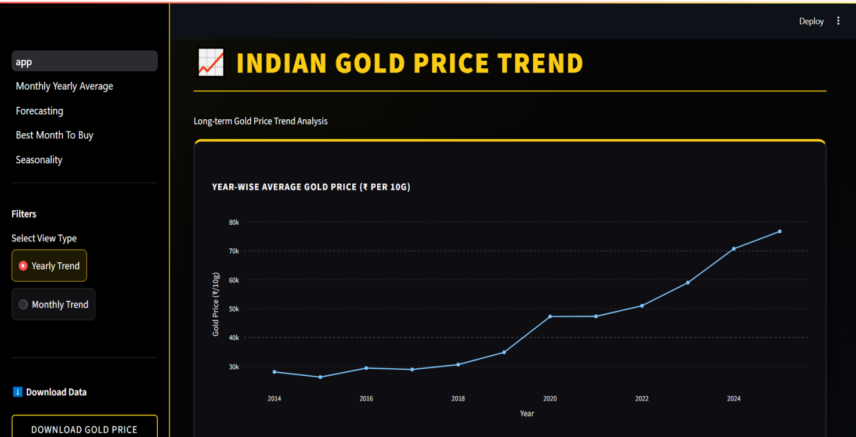

Monthly trend

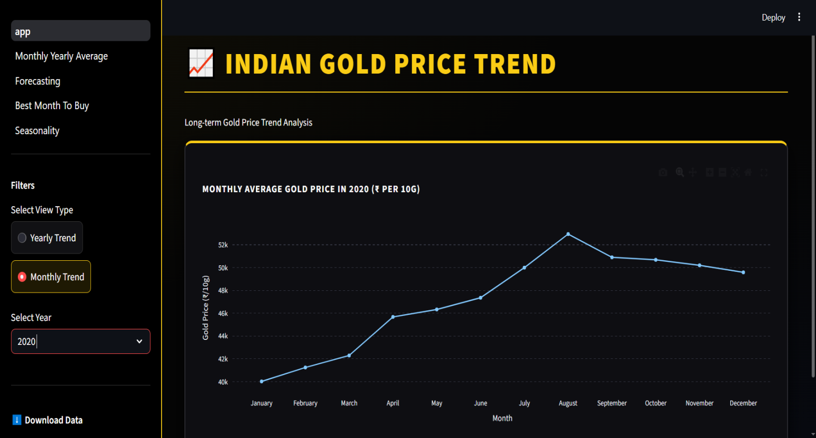

Yearwise average gold price

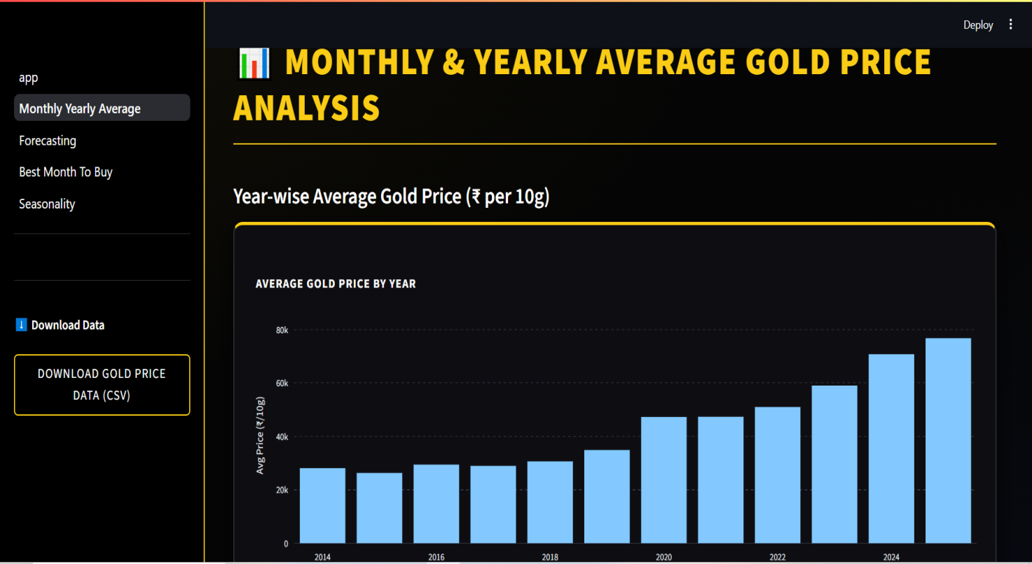

Month wise average gold price

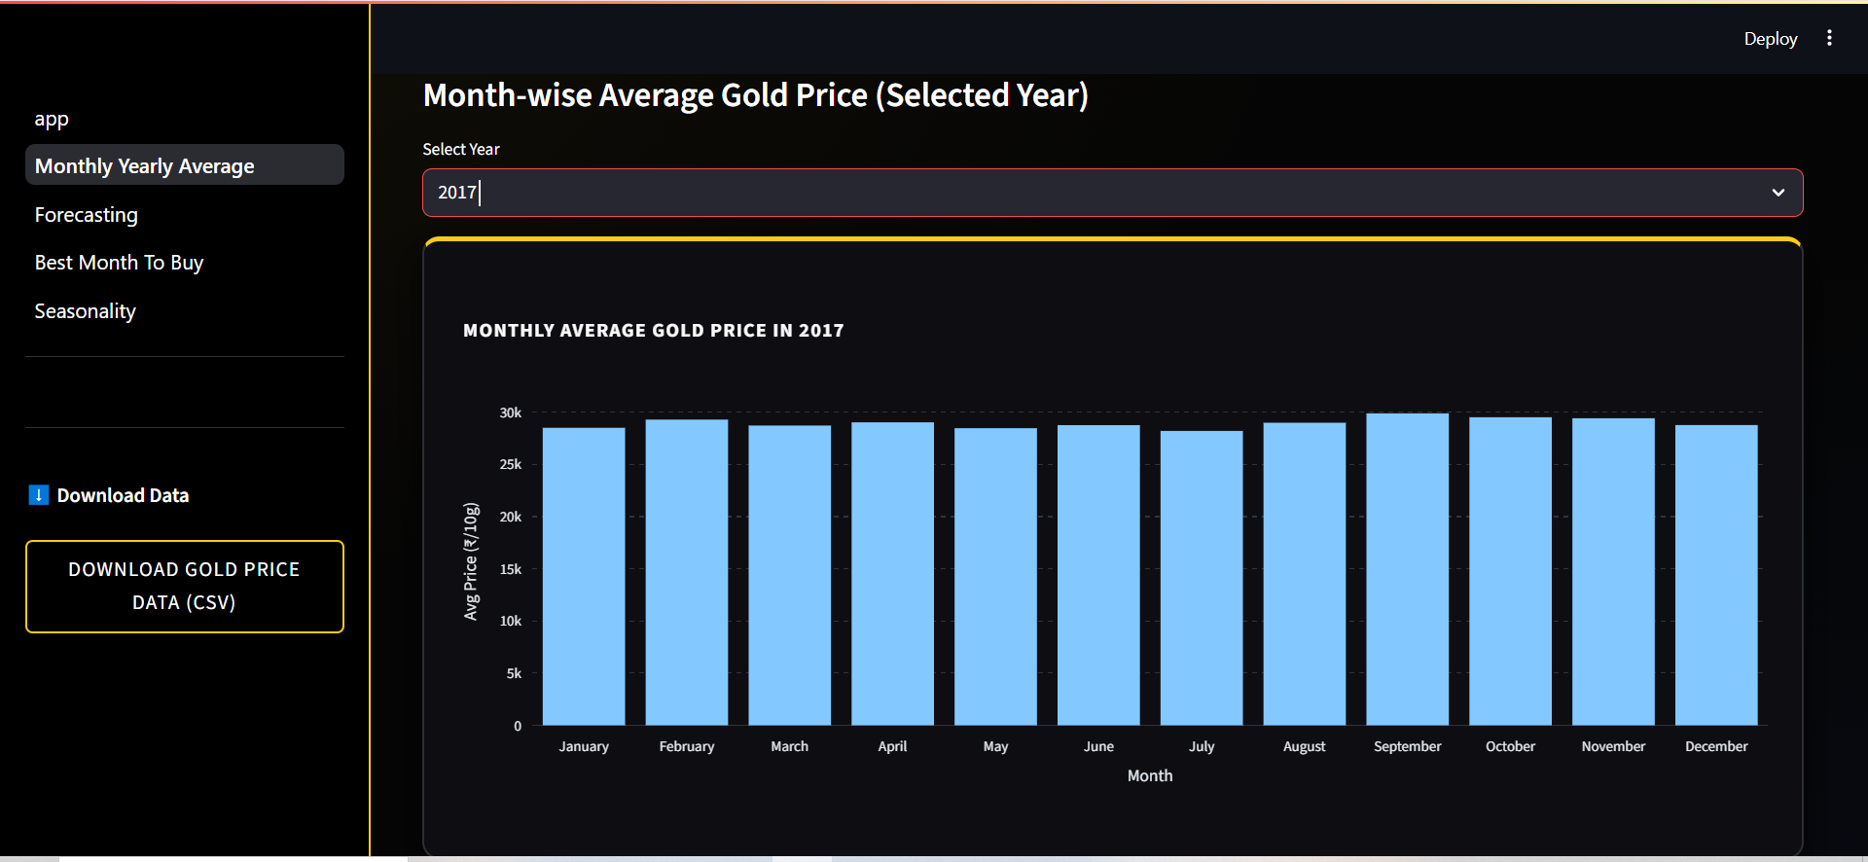

Gold price forecasting

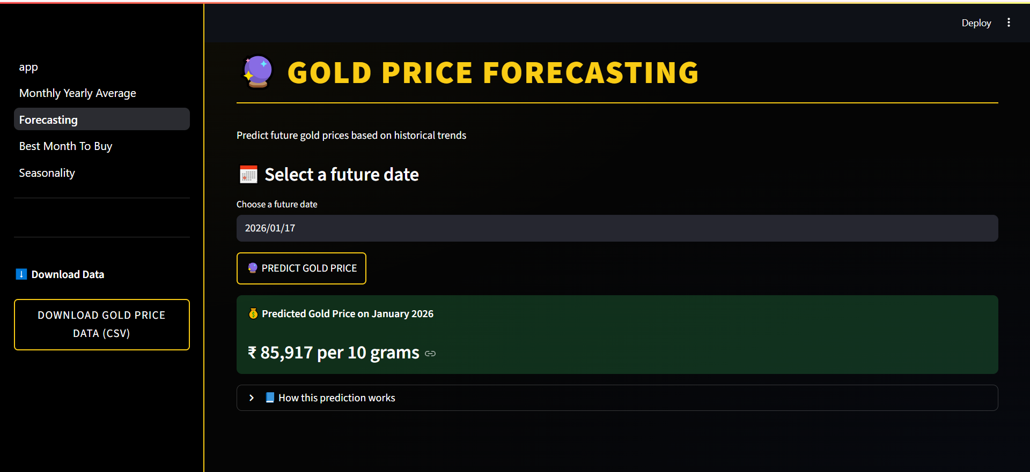

Best month to buy

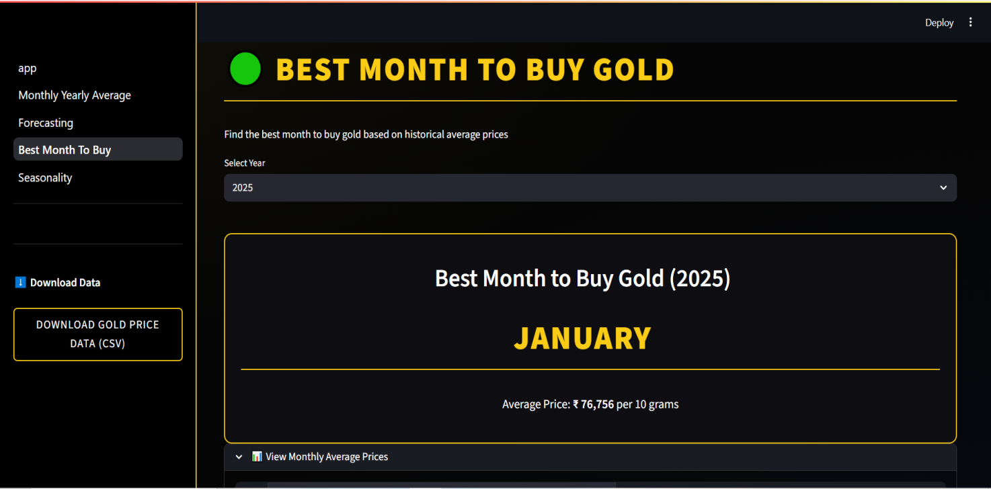

Season wise:

Line chart

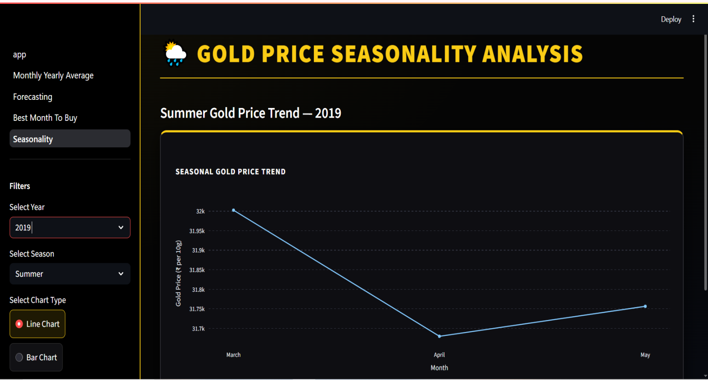

Bar chart

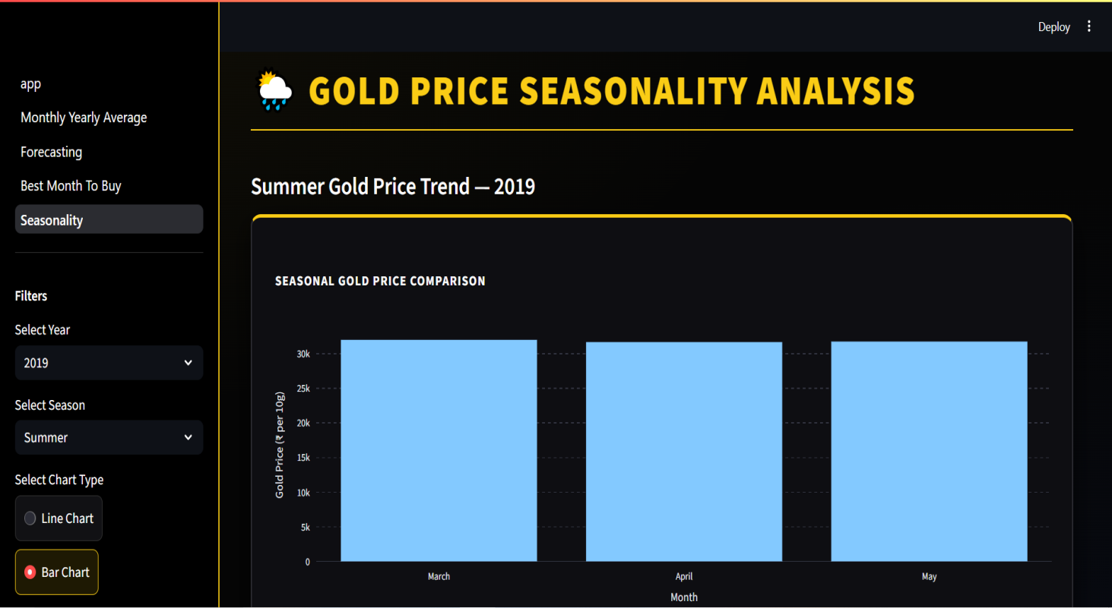

Download data

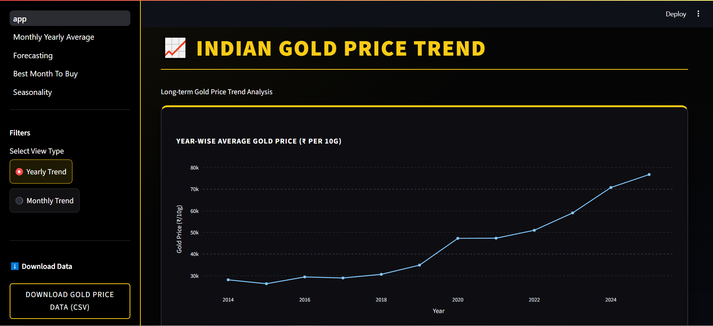

- Flow of the system:
START
↓
User Opens Gold Price Analysis Application
↓
Main Dashboard is Displayed
↓
User Selects Option from Sidebar
(Dashboard / Averages / Seasonality / Forecast / Best Month)
↓
User Selects Required Filters
(Year / Month / Season / Chart Type)
↓
System Displays Selected Gold Price Chart
↓
If Forecast Page Selected?
↓ YES
User Selects Future Date
↓
User Clicks Predict Button
↓
System Displays Predicted Gold Price
↓
NO
↓
User Views Analysis Results
↓
User Clicks Download Data Button (Optional)
↓
Gold Price Data Downloaded as CSV
↓
END

Conclusion
The Gold Price Analysis & Forecasting System successfully analyzes historical gold price data and provides meaningful insights through visual dashboards and forecasting. The project helps users understand long-term trends, monthly patterns, and seasonal variations in gold prices.
By using data science and time-series forecasting, the system predicts future gold prices and supports informed decision-making. This project demonstrates the practical application of data analysis, visualization, and forecasting techniques in a real-world financial scenario.
Overall, the project is useful, interactive, and educational, making it suitable for academic submission as well as real-world learning.

